JANUARY PERSONNEL NEWS

Employment law: what to expect in 2025
Consultations on employment rights bill to begin
Published in October 2024, the employment rights bill includes 28 individual reforms regarding the delivery of its Plan to Make Work Pay.
The legislation removes the two-year qualifying period for protection from unfair dismissal, as well as introducing day-one rights to paternity leave, parental leave and bereavement leave. The measures also include the removal of the lower earnings limit and four day waiting period for statutory sick pay, and the introduction of flexible working as a ‘default’ right from day one for all workers,
.
While the majority of these reforms will likely not take effect until 2026, with the government specifying reforms of unfair dismissal will take effect no sooner than Autumn 2026,

Draft Equality (Race and Disability) Bill
This will solidify the full right to equal pay for disabled individuals and ethnic minorities.
For organisations with over 250 employees, the bill will mandate ethnicity and disability pay gap reporting,
Statutory code of practice for right to switch off
The government plans to introduce the policy through a statutory code of practice, which will prevent employees from being contacted outside of working hours, except in exceptional circumstances.

Neonatal Care (Leave and Pay) Act 2023
This act, expected to come into effect in April 2025, will give parents up to 12 weeks of paid leave if they have babies who are admitted into hospital. The baby must be admitted up to the age of 28 days and have a continuous stay of 7 days or more. The act will have a minimum entitlement of one week.
In order to qualify, an employee must be employed for a minimum of 26 weeks prior to the leave being requested, and be earning an average of at least £123 a week. This mirrors the entitlement to maternity pay. The leave must also be taken in the first 68 weeks of the baby’s birth. .
National Minimum Wage increase
The national minimum wage increase will come into force on 1 April 2025. The national living wage will increase by £0.77 to £12.21. For 18-20 year olds, minimum wage will increase by £1.40 to £10.00 an hour, and for 16-17 year olds it will increase by £1.15 to £7.55 an hour.
“
Statutory payments increase
Statutory payments are legal entitlements granted to employees in certain circumstances such as illness, maternity, paternity, or bereavement. From April 2025 several statutory payments rates in the UK will increase.
The statutory sick pay (SSP) will rise from £116.75 to £118.75 per week, with a qualifying threshold of £125 per week. Under the proposed Employment Rights Bill, sick pay could soon be payable from the first day of being ill, however this will likely not be in effect by next April.
The statutory maternity pay, maternity allowance, statutory adoption pay, will rise from £184.03 to £187.18 per week.
“Most employers will still be able to reclaim 92 per cent of workers' statutory pay for maternity, paternity, adoption, and so on. This, together with the increase in the employment allowance to £10,000, will ease the impact, especially for vulnerable smaller businesses,” he explained.

Antenatal appointments
The male partner has the right to time off work to go to 2 antenatal appointments with their partner. This time off is usually unpaid and is for a maximum of 6.5 hours for each appointment.

Normally it will be much less but if there is a long journey to the appointment and the female has to wait for a consultant there might be a delay

Buying or selling your business
On the date of the transfer, the new employer becomes responsible for any outstanding wages or unpaid bonuses.
For example, an employee is transferred to a new employer in January. Their old employer previously paid a performance-related bonus in March. Their new employer is now responsible for paying them the bonus in March every year.
The new employer also becomes responsible for:
- any outstanding holiday
- any arrangements to carry over holiday from previous leave years
- enhanced or contractual holiday — where employees get more than the legal minimum
For example, an employee's holiday year starts on 1 January and ends on 31 December. They have 10 days' holiday left when they transfer on 1 October. Their new employer must allow them to take this holiday before the end of their leave year, if the employee wants to.
The new employer is responsible for these things even if the old employer did not include them in employee liability information.
If employee liability information was missing or inaccurate, the new employer could make a claim to an employment tribunal.The message is check this detail out

APRIL 2025 NEW RATES FOR EMPLOYERS

The government have announced the new rates for family leave and statutory sick pay which will apply from 6th April 2025.
The average gross weekly earnings required to qualify for the various forms of family leave pay will increase from £123 or more per week, to £125 or more per week from 6th April 2025. The figures stated are the maximum payable (under statute) per week. If an employee earns less per week than the rate stated, then they should receive the lower amount equating to their actual earnings

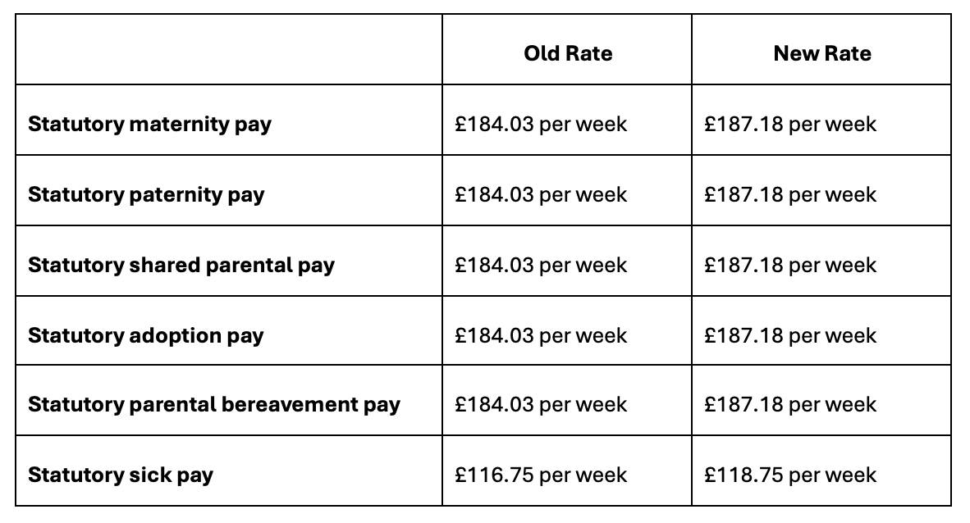

EMPLOYEE DIDN’T ATTEND TRIBUNAL

Its almost a guilty plea
An Aesthetics business was taken to tribunal and didn’t attend the hearing
The tribunal found the employee won her case as follows EASY IF THERE IS NO DEFENCE

- The complaint of breach of contract in relation to notice pay cost £1360
2 The complaint of unfair dismissal was successful
4. The Tribunal does not reduce the award under the principle in Polkey v AE Dayton Services Ltd. This is where ( if a fair procedure had been followed the employee might have won)
5. The employer didn’t comply comply with the ACAS Code of Practice on Disciplinary and Grievance Procedures
So the award was increased by 25 % .
The basic award of £2040 and a compensatory award of £16 394

